

DELEGATE CONFIRMATION FORM

Business Mission to Austin, Texas

ONE FORM PER COMPANY

COMPANY REPRESENTATIVE(S) INFORMATION
Representative #1
Title: Mr
Name: [Team member]
Designation: CEO and Founder
Mobile No: +1 [phone redacted]
Email Address: ivan@ambientsystems.ai
Dietary Restrictions: N/A
Please insert headshot photo of Rep #1 in colour below:


COMPANY PROFILE
Year of Establishment: 2021 (Singapore)
Please provide below profile of company (not more than 150 words).
Ambient Systems is building a software solution to help businesses improve financial performance. By combining IOT data from site operations with traditional finance processes, companies can gain a competitive advantage and improve their financial performance as measured by the double or ‘triple’ bottom line. Our software focuses on smart infrastructure industries that are overlooked by traditional ERP and FP&A software vendors. These include construction, transportation, and commercial real estate. We’ve demonstrated the technology at a vertical farm in Singapore (a niche use case for urban commercial real estate) where we identified ways for the client to improve their crop yield and output by 25% to 75% using IoT sensor data and machine learning. We’ve secured a patent for this invention as well as numerous other awards for the prototype, including first runner-up at a Google [Team member] in Singapore and a winner of the Panasonic deep tech innovation challenge.

PRODUCTS/SERVICES
Please provide below list of your products/services for the intention of the US market:
Ambient Systems provides a software solution for improving financial performance in the smart infrastructure industries. We are offering hourly services and custom engagement contracts for clients who are looking to enhance financial performance through use of AI and IOT for operational data in construction, transportation, commercial real estate, and vertical farming. The platform bridges the operational data from IoT with traditional finance team’s processes and uses AI to generate insights. We help finance teams get the data they need from other enterprise systems as well as site operations while enabling operational teams to leverage this data for greater insights into operational efficiency, improving the overall financial performance of the business.
In US, we want to offer the solution to the smart infrastructure industries like construction, commercial real estate, and transportation. We’re currently adapting the product for the Hong Kong market and think similar adaptations can be done for the US market, namely around data compatibility and meeting regulation and compliance requirements.

CUSTOMER PROFILE
Past/Current Major Customers: Vertical farming POC in Singapore, Google [Team member] Singapore, Panasonic Deep Tech Innovation Challenge
Target Customers for this Mission: transportation, construction, commercial real estate

COMPANY BRAND
Corporate Logo Please paste below 4-Colour and 1-Colour PNG formats of logo with transparent background.
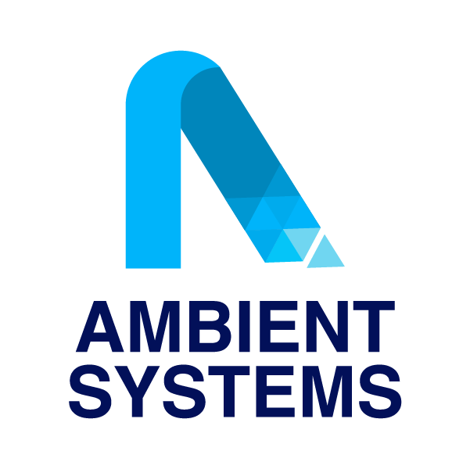

OBJECTIVES OF MISSION
Please list minimum of 2 objectives.

Our number one goal is to secure a pilot customer in one of the industries where we can demonstrate our deep tech capabilities: transportation, commercial real estate, construction, or vertical farming. We also aim to start conversations with investors at seed stage for fundraising discussions once the upcoming rounds open. We are currently focused on generating customer interest and securing commercial contracts.

EXISTING US PRESENCE (IF ANY)
Please describe your experience (if any) in the US and advise if you have a distributor, local agent or representative.

None at this time.

GENERAL INFO
Other Comments

Ambient Systems is headquartered in Singapore with regional locations in Hong Kong and Quebec, Canada. We would be delivering the service to US clients through one of these entities or through a new one set-up in US, depending on the client’s and investor’s preferences.

Website: www.ambientsystems.ai

